Unit compelling question: Why do we consider those with whiter skin and features more beautiful?

Texts:

As Racism Wanes, Colorism Persists | Brent Staples | New York Times article
https://theboard.blogs.nytimes.com/2008/08/22/as-racism-wanes-colorism-persists/

Brent Staples informs the reader of the ways institutions favor those with lighter skin over those with darker skin: lighter-skinned people are more likely to be employed, voters preferred lighter-skinned candidates over darker-skinned candidates, lighter-skinned Blacks are more likely to receive shorter sentences than darker-skinned Blacks, and darker-skinned Blacks are more likely to receive the death penalty. He notes that society has a fetish for light skin and Eurocentric features that “affects how people vote; who appears in Hollywood movies and television news shows; who gets hired and promoted in corporate America; and even who gets executed for murder”. These colorist practices can be traced back to a white, slave-owning society preferred lighter-skinned Blacks, and as a result, our society has developed this hierarchy based on skin color.

Confessions of a D Girl: Colorism and Global Standards of Beauty | Chika Okoro | TEDxStanford | Youtube video
https://www.youtube.com/watch?v=fvoWoMIwr-g

Chika Okoro begins her TED talk with an anecdote: reading a casting call that characterized dark-skinned girls as “D girls” – less desirable than lighter-skinned “A girls”. Okoro points out and criticizes society characterization of light skin, light eyes, long, soft, and real hair as “desirable” but laments that “[it’s] just the way it is.” One can blame colorism, which is just as sinister and subtle as racism and started with slavery and the mass rape of African American women by white men. Colorism exists within the Black community that prefers those with more Anglo features. There are demeaning and colorist “tests” to determine if one’s skin is light enough (brown paper bag test), one’s hair is straight enough (pencil test), and one’s silhouette matches that of a silhouette with “Caucasian features” (shadow test). In order to achieve what we have been led to believe is beautiful, women have become consumers supporting a huge skin-whitening product market. In India and Asia alone, skin-whitening products are a multi-billion dollar business. Okoro offers more examples of the pervasiveness of this colorist “white is most beautiful” belief: Black celebrities’ having their skin lightened on magazine covers and young children being more likely to choose the lighter-skinned girl as “popular” and “pretty” and the darker-skinned girl as “ugly”. Okoro ends on a hopeful note, stating that because beauty preferences are learned, they can be unlearned. She calls for awareness and for companies and media to make the unconventional choice and for us all to not passively accept what society has told us is beautiful.

Is Beauty in The Eyes of The Colonizer? | Leah Donnella | Code Switch Podcast/article
https://www.npr.org/sections/codeswitch/2019/02/06/685506578/is-beauty-in-the-eyes-of-the-colonizer

Our society has made white feminine beauty the standard of beauty. This white femininity, however, is only accessible to a select few. This standard of white beauty has been internalized and “colonized” by society. Throughout history, “white” or “Caucasian” has been considered the most beautiful of the races and as a result, the “association between beauty and whiteness has proved hard to shake”. Dark-skinned women do not receive the same validations for their beauty. What society considers beautiful does matter because beauty is a “facet of power. Being considered beautiful can help you gain access to certain spaces, or increase your power in certain settings”. The white feminine standard of beauty has been pushed back on, such as by the Black is Beautiful Movement of the 1960s and ‘70s. We can also start with ourselves and decolonize our own personally held ideals of beauty by telling ourselves that all faces, bodies, and skin colors are beautiful and valuable.

A moment that changed me: rejecting the white ‘prettiness’ ideal | Eliza Anyangwe | online article
https://www.theguardian.com/commentisfree/2017/apr/14/moment-that-changed-me-white-prettiness-racist-beauty

In this article, Eliza Angyangwe tells of her personal struggles with idealizing the white standard of beauty and constantly comparing herself to this ideal. She would pinch her nose to see what it would look like post-surgery and would skip class to go to the gym, all to achieve what society told her was most desirable to men: Eurocentric features and whiteness. After years of believing she needed to change her face and body in order to become desirable, Anyangwe started the process of reversing all the ideological ideas and expectations of beauty she had internalized, “owning [her] beauty in all its diversity” and being free from white beauty standards.

Colorism in South Korea and its Reflections in K-pop | Lindsay Wong | online article
https://www.overachievermagazine.com/opeds/jc5mn2jcwdk4fxbchzdo6owzze99mk

The K-pop industry has gained global popularity but it is also no secret that pale skin is heavily favored in the industry. In South Korea, lookism is very prevalent, with South Korean society placing a heavy emphasis on appearance. Historically in Asia, pale skin has been a marker of social status and class. More recently, Western societies have been considered more modern and advanced, leading to fair skin maintaining its superiority. The K-pop industry receives incredible attention from young people around the world, and the popularity of the industry has spread beliefs in the K-pop industry that milky white skin is superior to tan skin. K-pop idols receive more backlash for being tan but receive praise and favor when they have milky white skin. In the K-pop industry, pale skin means a pure image, leading to better branding and more profit.

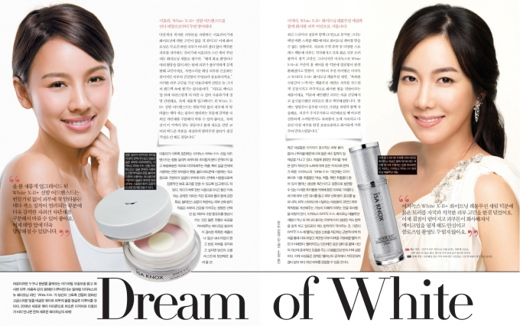
Image link:
http://cosmeticschinaagency.com/wp-content/uploads/2020/11/dream-of-white.jpg

The image above is an advertisement for skin-whitening products. The ad promotes the belief that pale skin is most beautiful and most desirable by using fair-skinned models and the phrase “Dream of White”.

Image link: http://atlantablackstar.com/wp-content/uploads/2015/02/Lupito-cover-resize.jpg

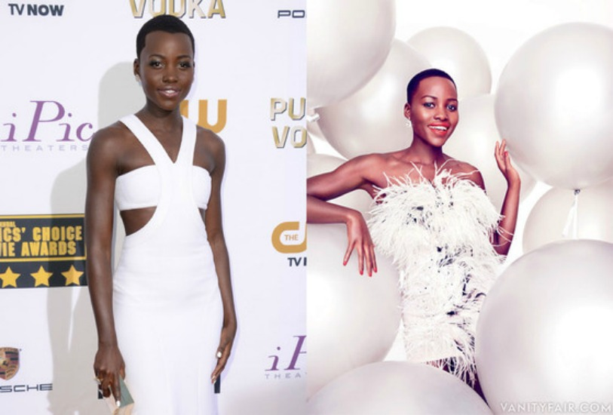

Image link: https://curlsunderstood.com/wp-content/uploads/2015/03/curls-understood-lightening-black-celebrities-on-magazine-covers-beyonce.jpg

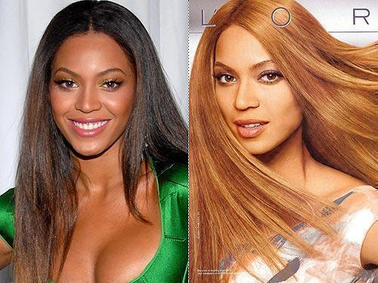

These two images of Lupita Nyong’o and Beyoncé being lightened for magazine covers were shown in Chika Okoro’s TED talk as examples of lighter skin being more desired by society and this message being perpetuated by the media. Having already discussed these images in the video, they have been provided again in the text set to give students a chance to look at them more closely.

